Volume

1

Handle with Care Burn Scar Massage Therapy

Caregiver s Basic Massage Principles

Handle With Care Burn Scar Massage Therapy

2028 West Oldfield Street

Lancaster, CA 93536

Phone: 706.831.2889

Email: hwcmassage2004@gmail.com

Table of Contents

Table of Contents 2

Burn Survivor vs. Burn Victim 3

Types of Burns 5

Degrees of Burns 9

Physical and Emotional Benefits of Massage 14

Centering, intention and Being Present 19

Basic Massage Techniques 20

References 24

Burn Survivor vs. Burn Victim

***Why is it so important?***

Your family member, loved one, or friend has just underwent one of the most devastating injuries a human can endure. Your experiences have been just as difficult, watching your friend or family member suffering and hoping for the best but unsure of what the future has in store. We believe that positive reinforcement is not only important but proven to be effective in helping a person recover from an injury.

A burn survivor is anyone that survives the injury. A burn victim did not live. No matter what stage of recovery, no matter their mental state…..a person who lives to tell their story is a SURVIVOR!!!!

This is extremely important for two reasons:

1. We want to perpetuate positive feedback. The survivor may still be in a “victim mentality” but we do not want to reinforce a negative belief. The survivor lived through a devastating and excruciatingly painful experience to tell their story. Their story of survival is one of courage and endurance. A testimony to the resilience of the human spirit and our fight for existence.
2. You will insult most burn survivors if you call them a victim.

Research supports positive reinforcements and how much language and positive reinforcement can have on human development and recovery from a traumatic experience, as well as, assisting humans to live a longer and healthier life. A book written by Andrew Newberg, MD and Mark Robert Waldman called “Words Can Change Your Brain” shows the physiology that goes along with this belief. Humans have a fear center in our brain. This center is important for survival and tells us when to run or fight when danger approaches. Research shows that negative words will actually cause the fear center to over-react and can actually shut down the logic-and-reasoning centers in our brain. Positive words actually strengthen our frontal lobe and promote cognitive functioning.

So saying the word victim, can actually slow down your survivor’s recovery process. Keep the word SURVIVOR in your vocabulary along with lots of other positive words and actions. Being positive is not always easy and we all have days that seem worse than others we just need to keep on moving towards recovery both physical and mental. Your survivor’s recovery, as well as your own recovery, is vital. A lot of caregivers suffer through anxiety, post-traumatic stress disorder, guilt, anger, etc. Positive affirmations should be spoken over yourself every day.

Some suggestions to keep yourself on track because if you are not healthy, it’s difficult to help your survivor:

1. Get plenty of rest. Sleep is important. If you’re exhausted, it’s easier to become depressed and you don’t have the energy to be helpful.
2. Drink water and eat regular meals.
3. Take a walk or do some form of physical exercise for 30 minutes every day.
4. Write positive mantras and place them on sticky notes on your refrigerator, bathroom mirror, car dash, wherever you look often during the day.
5. Laugh. Find time to laugh. Watch a funny television program or movie, act silly with your family, read a funny book. Laughter is contagious.
6. Seek counseling for your own struggles.
7. Seek support groups.
8. Love yourself.

You will notice a lot of burn survivors use humor as a coping skill. Some humor may seem in poor taste or difficult. For example, Jen was burned in hot water as a baby in South Georgia. She refers to herself as a boiled peanut. This bothers her mother because her mother after 41 years still struggles with guilt. But Jen uses this humor as a coping mechanism. So don’t be surprised if you hear some strange things in the presence of burn survivors, especially a group of survivors. It’s okay to laugh with them.

At the same time, let your survivor make the funny comments first. They may not be ready for humor at this stage of their recovery. Every survivor is different and has their own journey to travel.

Types of Burns

**Atrophic Scars:**

Atrophic scarring is common with acne scars. These are sunk in scars or pitted areas on the skin. They appear with burn survivors who are missing fat and muscle tissue. You can still massage atrophic scars but you may need to use light pressure on large atrophic scars.

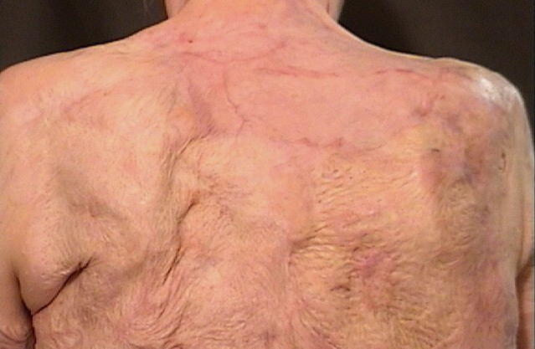

**Hypertrophic Scars:**

Hypertrophic scars are raised scars on the actual site of the injury. Some people are more predisposed to get hypertrophic scars. Jen has hypertrophic scarring from not wearing her pressure garments when she was a child. The pressure garments function as skin and add the pressure where normal skin is missing. If your survivor needs to wear pressure garments or Jobst, encourage them to follow their doctor’s advice. They should be worn 23 hours a day for as long as the doctor prescribes.

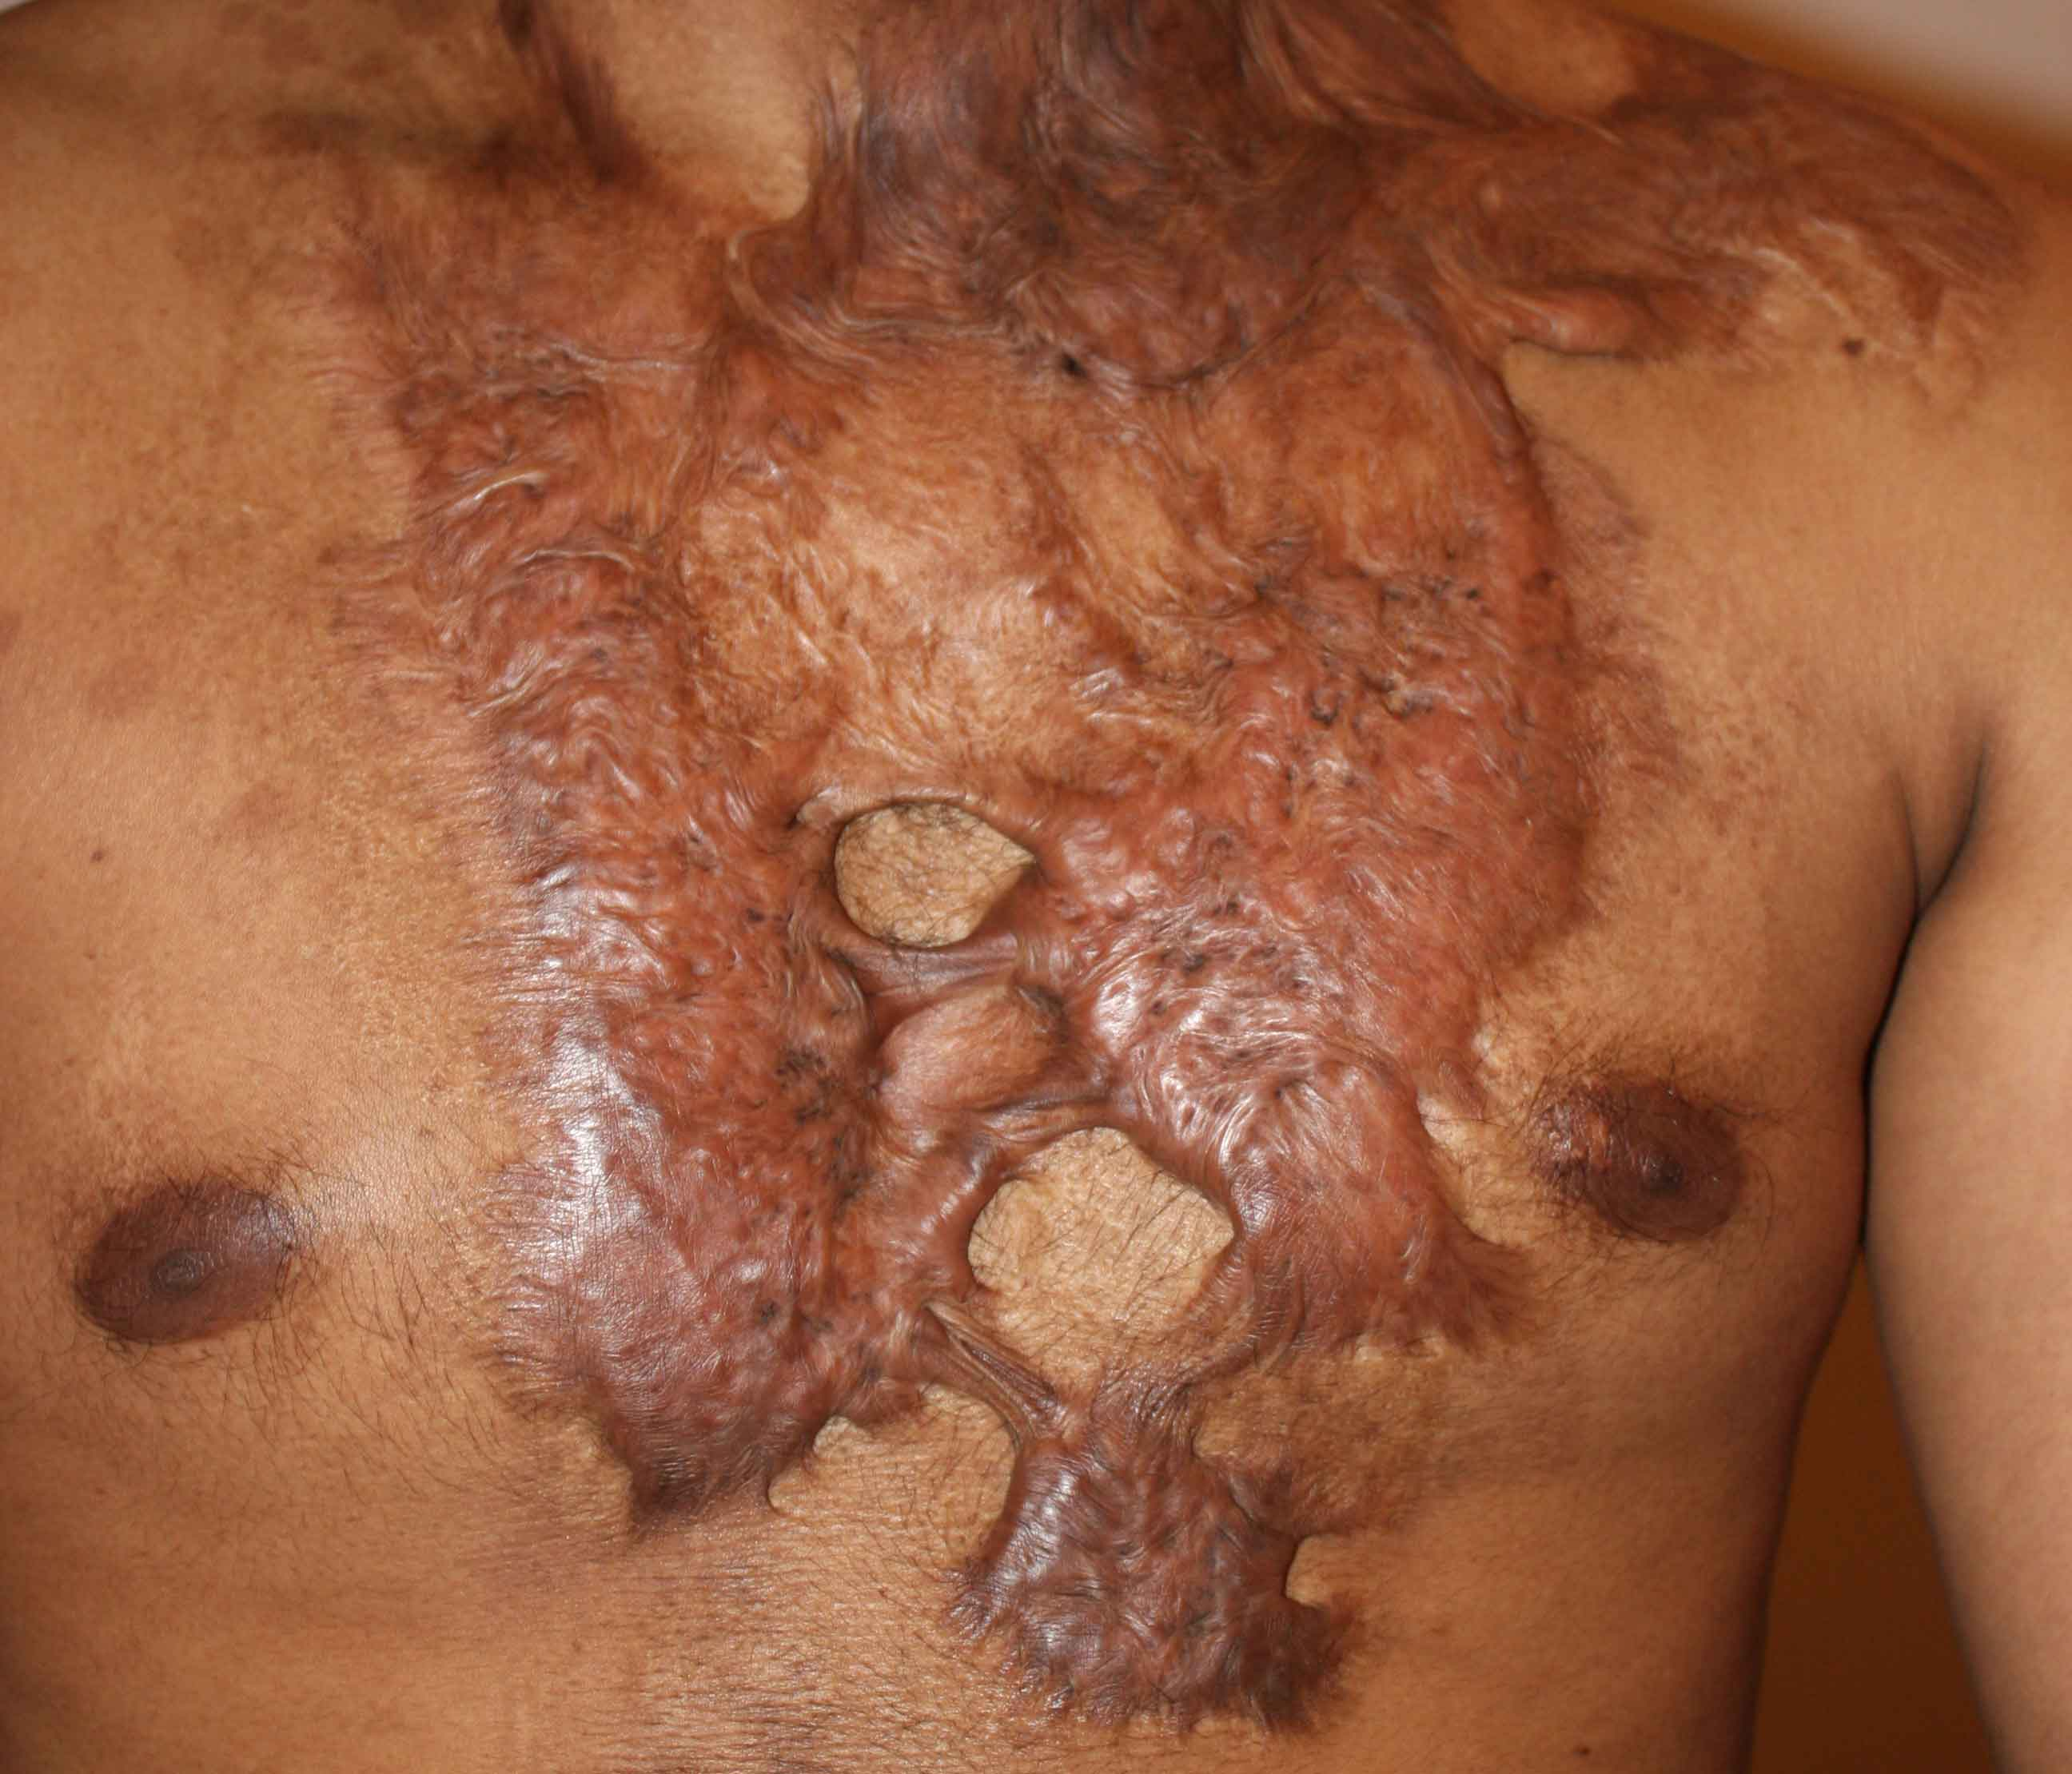

**Keloid Scars:**

Keloid scars are raised scars that overflow the wound site. They are more prevalent with darker complexions but they can appear on anyone. Keloids are considered a type of benign tumor. Keloid scars can be painful emotionally and physically. Different procedures are being used to alter keloid scars but often times the procedures are only temporary. Keloid scars often have long term problems with itching after the scar has completely healed.

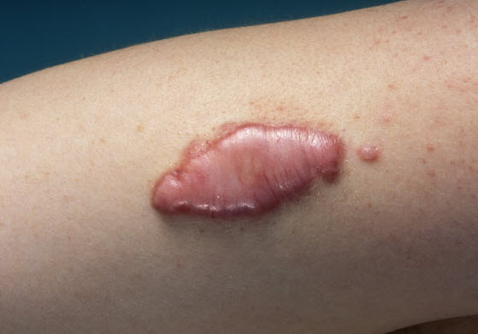

**Contractures:**

Contractures refer to a tightening of the skin after a second or third degree burn. When the skin is burned, the skin around the wound begins to pull together, resulting in a contracture. Contractures usually follow the line of movement and are fairly common around joints. Massage can help with contractures but special care needs to be used not to pull across a contracture. Massage in the same direction as the contracture. Massage will not make a contracture go away. If the contracture is limiting the survivor’s movement or causing pain, surgery will need to be performed.

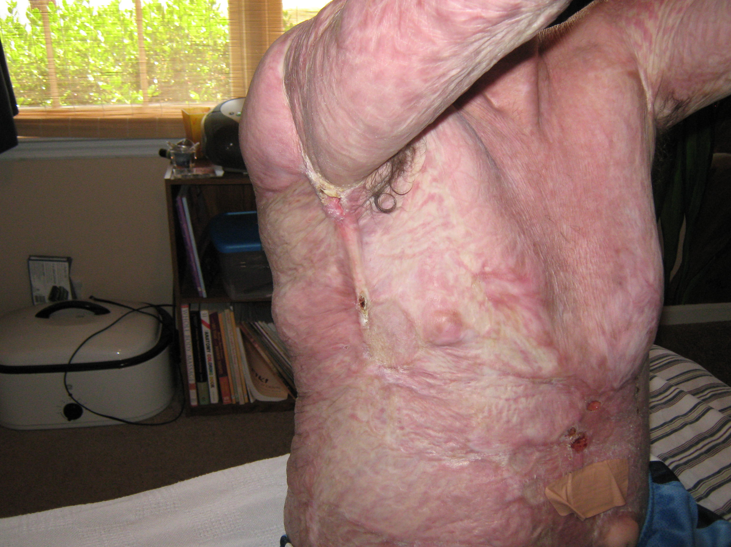

Not all scars fall into these categories. Some scars are relatively flat and only appear discolored. Some scar tissue can be very thin in places. You will be able to massage all of the various burns and we will discuss how to address the burns in the massage technique section of this manual.

Degrees of Burns

Our skin is made up of an epidermis and a dermis layer. The epidermis is the outer layer and the dermis is the inner layer. Your dermis layer is where your new skin cells are generated. Humans regenerate skin every day. The old skin sloughs off and new skin originating from the deeper skin layer continues to make new skin. The diagram below shows how deep each burn is in relation to your skin. Our skin is the largest organ in the human body and it contains blood vessels, nerves, hair follicles, oil glands, and sweat glands. Our skin’s first and most important function is to protect our body from foreign matters and damage. Our skin also regulates body temperature, synthesizes vitamin D from sunshine, senses touch including danger and pain, stores fat needed for vital organs, and excretes waste through our sweat glands. With a large burn, all of these functions can be compromised.

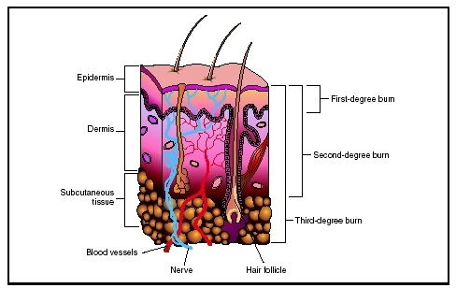

**First Degree Burn:**

First degree burns damage just the top layer of the skin, the epidermis. The burn appears red and is painful but should heal without any significant scarring within 7 days. Most sunburns would be classified as a first degree burn.

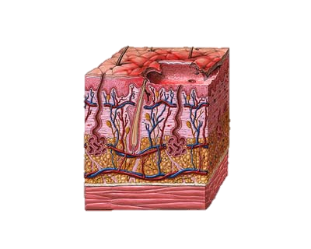

**Second Degree Burns:**

Second degree burns damage both the dermis and the epidermis. All of the epidermis is destroyed along with a portion of the dermal layer. There are two types of second degree burns A superficial second degree damages the very top layer of the dermis and is extremely painful because nerves are exposed. The wound will have blisters and swelling but it will normally heal with very little scarring in about 21 days. A deep second degree burn extends into the deeper portions of the dermal layer. A deep second degree burn is generally painless because the nerve endings are now damaged. Blistering is less noticeable but you may see signs of blackened skin. Deep second degree burns may progress to a third degree burn and often requires a skin graft to heal properly.

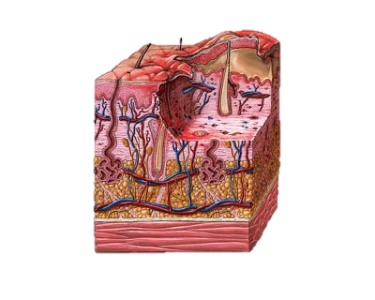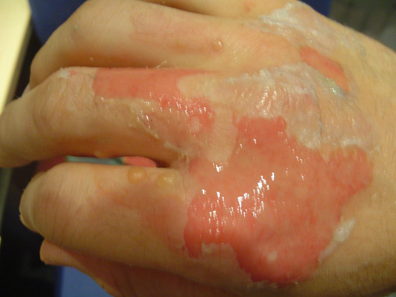

**Third Degree Burns:**

A third degree burn damages both the epidermis and the dermis completely and reaches into the underlying fat layer. The wound appears stiff, waxy white, leathery or tan. The burn destroys nerve cells causing numbness. Almost always, a third degree burn will require skin grafting and almost always involves significant scarring.

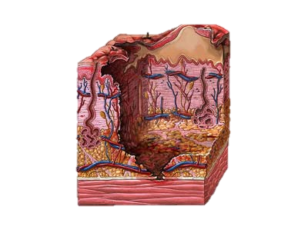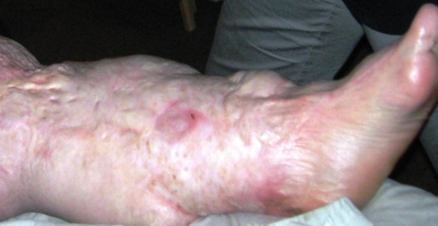

**Fourth Degree Burns:**

The burn goes through all layers of the skin, through the fat layer and into the deeper structures. Fourth degree burns damage muscles, tendons and bones. If the bone is damaged, amputation will be required because our body does not regenerate bones. Fourth degree burns have a very high rate of infection.

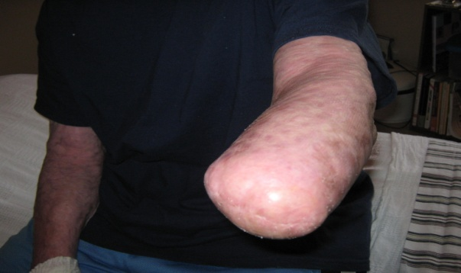

Physical and Emotional Benefits of Massage

1. **Increases Range of Motion – Collagen Remodeling**

Scar tissue can cause restrictions. Scar tissue is 20% on the surface and 80% underneath the skin. So tissue can be pressing on muscles, nerves and joints. Scar tissue can also bind to the underlying tissues. Muscles work by sliding along each other. If scar tissue is binding muscles, they may not move as they did prior to the accident. Studies have shown that implementing massage greatly increases range of motion. New scar tissue will show greater results than older scar tissue but massage is beneficial for all scar tissue.

“*Analysis of various disorders resulting from abnormal deposition of collagen indicates that it is not the volume or amount of collagen that accumulates in the tissue lesion, but rather the physical properties (maturation, polymerization) of the collageneous matrix that are responsible for the dysfunction of the affected tissue organ,” write M. Chvapil and C.F. Koopman. “Once collagen is stabilized, it is more resistant to degradation by tissue collagenases. The dense, rigid scar of mature collagen binds less water”[1]*

Scar tissue massage is a simple solution to achieving freer movement by loosening restrictive areas and achieving a greater range of motion.

1. **Increases Pliability**

Scar tissue can be dry and inelastic. As described above dense, rigid scar tissue has less water. Various massage techniques can warm up the tissue, increase circulation, and therefore brings more pliability to the scar and the surrounding tissues. You will note a difference within a few minutes of doing warm up strokes that the tissue will begin to move and you will be able to manipulate the scar, or the surrounding tissue or both.

1. **Provides Moisture**

Scar tissue is missing oil glands and sweat gland, which assist with maintaining moisture. Applying lotion will assist with keeping the skin hydrated by maintaining a moisture barrier.

1. **Increases Circulation**

Current research indicates some debate on whether or not massage actually increases circulation. This statement is taught in most massage schools and training manuals. Research with just massage without stretching has not shown a significant increase in blood flow but adding stretching has shown increases. More research needs to be conducted. We have witnessed first hand an increase in lymphatic flow. Jen’s urine was almost black from moving lymphatic flow after a two hour massage on her legs. You will notice the skin color will change as blood moves into the tissue. You will normally notice a decrease in swelling where lymph begins to flow.

1. **Reduces Itching**

Itching is a common problem in burn scars because scar tissue is dry and missing oil glands. Initial itching is due to the healing process but long term itching is even more prevalent in hypertrophic and keloid scars. Research is still ongoing as to the exact cause of long term itching in hypertrophic and keloid scars.

“*The cause of this itch phenomenon is not only related to histamine release but recent studies suggest a histamine-independent pathway for itch.” [2] This may occur via a direct activation of opioid receptors, which have recently been identified in the skin.“ [3]*

Extreme itching can be a serious concern. Scratching the scar tissue can cause the wound to reopen and may even require additional surgeries to close the wound. Applying lotion and manipulating the scar tissue can assist with itching.

1. **Provides Healing Touch**

Severely disfigured burn survivors may find it difficult to leave their house and face public stares. S.C.A.R.E.D. is an acronym for how a severely disfigured burn survivor feels when they encounter a survivor. The acronym created by Changing Faces represents how the burn survivor feels and the people feel that they encounter in social situations:

|  |  |
| --- | --- |
| Burn Survivors | |
| Feeling | Behavior |
| Self-conscious | Shy |
| Conspicuous (noticed) | Cowardly |
| Angry, Anxious | Aggressive |
| Rejected | Retreating |
| Embarrassed | Evasive |
| Different | Defensive |

|  |  |
| --- | --- |
| Others | |
| Feeling | Behavior |
| Sorry, Shocked | Staring, Speechless |
| Curious, Confused | Clumsy |
| Anxious | Asking, Awkward |
| Repelled | Recoiling, Rude |
| Embarrassed | Evasive |
| Distressed | Distracted |

*Changing Faces* is working to change interactions between burn survivors and the outside world. Hospital workers who are already interacting with the burn community tend to already treat burn survivors with respect and as a whole person. The effort is helping your burn survivor assimilate once they leave the hospital and teaching survivors how to interact on a daily basis with people outside of the medical profession.

Survivors with less noticeable scars may still have body image issues and psychological ramifications from their burns. Not all survivors are burned accidentally. We have met a lot of burn survivors who were burned deliberately. You will meet burn survivors that appear to be confident and are functioning well with their scars. All of these scenarios will still benefit from just being touched. Without doing any special techniques, simply touching their scars is a healing process. Your touch may elicit an emotional release, which we discuss below. Emotional releases are common with someone who has been touched very little after discharge from medical care or only touched in a painful manner prior to massage. Emotional releases can be healing and empowering.

1. **Reduces Anxiety and Depression**

Studies have been conducted at the University of Miami regarding reducing anxiety and depression. Studies have concluded that massage reduces cortisol levels and nursing staff noted decreases in anxiety and improved sleep patterns. Patients experienced an improvement in their moods post massage. Jen has witnessed this personally working on a burn survivor pre-surgery. The subject was hooked to a heart monitor and she watched his heart rate drop. When the nurse entered the room to administer pre-surgery anti-anxiety medication, the subject told the nurse he no longer needed the medicine.

We feel strongly that massage is just as important in treating the psychological effects as it is in treating the physical effects.

The psychological effects of burn scars or any major scars are:

* Anxiety
* Moderate to severe depression
* Nightmares
* Moderate to severe coping skill problems
* Trust Issues
* Intimacy Issues
* Post Traumatic Stress Disorder
* Poor Self Esteem
* Fear
* Suicide
* Anger

What is an emotional release? An emotion may be released during a massage. Emotions such as sadness, joy, fear and anger. The patient may cry, laugh, tense up, or become angry. One of the strongest human senses is smell. Our limbic center in our brain can remember a large variety of smells and associate smells with specific memories. Chris has experienced an emotional release during a massage session using the essential oil orange. During the first massage, Chris began crying for no apparent reason. She was unable to determine the cause of the tears but she also experienced a sense of relief and allowed the therapist to continue with the massage. Since that first massage, orange essential oil no longer brings tears but a sense of overall comfort. Perfumes, essential oils, colognes, scented candles….all can elicit an emotional release. A smell that was prevalent at the time of your survivor’s accident can create an emotional response.

Touch is also a strong sense for emotional release especially with burn survivors. We met a gentleman in Raleigh NC in 2008 who shared an experience with his wife. John was severely burned and disfigured from a gas line explosion. He met his wife after the accident so she has only known him with his scars. An intimate moment in bed, she touched his face years after the accident and he became extremely angry. He didn’t understand the anger at first and then realized that he was experiencing anger because he no longer felt like his face was truly his face. Even after many years of recovery, John was facing a new issue. He was able to process this information and take another important step in his healing process. Releasing pent up emotions can be extremely healing.

What should you do when a patient shows signs of an emotional release? Stop what you are doing but keep contact. Ask your survivor if they want to continue. If they do not, then end the session. If they are okay to continue, keep going but pay attention and keep checking in with their emotional state. A survivor may begin to open up and that is okay.

Centering, intention and Being Present

Have you ever experienced a sales clerk who was talking on the phone or typing on the computer while you were seeking assistance? A waiter or waitress who seemed distracted and brought you the wrong order? A friend or family member playing games on their phone when you are in the middle of pouring out your feelings? All of these create a negative experience and make you feel less than important.

Centering is a technique that clears your mind of any negativity or any distracting thought processes. You are centering your attention on what you are about to do and making the experience as pleasant as possible for your survivor. No longer wondering if you paid the phone bill or did you remember to turn off the iron. You are now completely focused on the task at hand. This is difficult to master, especially if your life normally entails multi-tasking. You are undertaking a lot of tasks throughout the day. Take a minute or two before starting a massage to mediate or say a prayer or simply just being quiet and still. Whatever technique works for you so that all of your intention is to create the best experience for your survivor.

Intention is another important massage technique. Per Webster Online Dictionary intention is the stretching or bending of the mind toward an object; closeness of application; fixedness of attention; earnestness. We have the intention of applying our knowledge to assist our survivor.

Being present in the moment is an extension of Centering. You continue to be centered on your survivor through out the session. Allot a certain amount of time and continue to stay focused.

Centering, Intention and Being Present will result in a positive experience for both you and your survivor.

Basic Massage Techniques

Massage has been around since ancient times and there are two main lines of thinking. Eastern massage is based on Traditional Chinese Medicine and Western massage is based on ancient Greece and massaging athletes and warriors. Eastern massage involves the way the energy flows through the body. Western techniques are based on anatomy and pathology. New forms of massage are created every year as research continues to develop. The main reason massage has lasted thousands of years is that humans need touch. It’s a basic need. Studies of infants that are touched very little show signs of adverse physical and emotional side effects.

We are going to teach you three massage techniques, types of lotions, different scar techniques, what to watch out for and how often you should massage your survivor.

**Types of Lotions:**

Cocoa Butter is an excellent massage medium. Believe it or not, some hospitals actually use Crisco Shortening. We know survivors who used olive oil on their burns. The best lotion would be the most natural and one that easily absorbs into the skin. Be cautious of heavy perfumes or lotions with a large number of chemicals. We have a burn scar cream called Burn Lift that will be on the market or is on the market depending on when you receive this manual. Test the lotion on an area that is not scarred prior to massaging if you are unsure. The last thing you want is an allergic reaction on the scar itself. Scratching a scar could reopen the wound and lead to infection or even additional surgeries.

**How to Apply?**

We are going to teach three massage moves. They are called: Effleurage, Petrissage and Friction. Effleurage and Petrissage were named in French for reasons unknown by a gentlemen named Johanne Mezger in the 1800’s and based on Swedish Massage created by Pehr Henrik Ling. Don’t let the names intimidate you.

Effleurage is simply a gliding stroke. Using your palms, fingers, forearm, side of hand, fists…simply gliding back and forth across the area. Most massages begin and end with this basic stroke. Make sure you have enough lotion to glide. On scars without any restrictions, this can be done in all different directions. On hypertrophic and keloid scars, start off light and you may need to go a little deeper with each stroke to get through the thick scar tissue. On contractures, perform gliding strokes around the contracture before applying pressure on the contracture itself. With contractures, make sure your gliding is with the contracture and not across it. This stroke can be very relaxing. You can perform gliding strokes with one hand, two hands, fist, thumb, fingers, forearm and even your elbow although we don’t recommend using your elbow without extensive training. We will demonstrate each technique in class.

Petrissage simply means a kneading stroke. Picking up the tissue and moving it if the skin can handle this move. Hypertrophic scar tissue may be difficult at first to perform kneading moves but once the tissue warms up you will notice it begins to have more movement. If you are unable to work on the scar itself, kneading on skin surrounding the scar can help loosen up the actual scar tissue. Kneading can be performed one-handed, two-handed, alternate hands, fulling and skin rolling. Fulling is grasping the tissue with both hands; lift it up and away from the bone while spreading it out laterally. We will demonstrate these moves but not all moves will apply to every scar.

Friction is pushing the tissue in several directions, either moving back and forth or in a circular pattern to create heat. Be cautious performing friction on contractures. Circular friction around the scar itself and along the borders is a great technique for loosening tight bands. Rolling friction can be done on extremities by placing the arm or leg in between your palms and moving hands in opposite directions. Wringing friction is also performed on arms, legs and fingers by grasping with the entire hand and moving back and forth and moving towards the heart. Cross fiber friction is moving against the grain. Muscle fibers run in one direction. Cross fiber would be moving across the muscle. Do not complete cross fiber friction on contractures. Circular friction uses small circular movements that push into the tissue.

While performing a move, watch your body mechanics. Don’t hunch, keep your upper body straight. If you are standing, lunge slightly and keep your knees bent and soft. Don’t just use thumb and fingers. We will demonstrate each move in class and go over basic body mechanics. We will work with you and your individual burn survivor to come up with the best sequence of moves. This manual is simply for a refresher and not meant to be followed exactly. Each burn survivor should be treated as an individual and no one treatment works for all.

**What to Watch Out For?**

Do not apply pressure to the following areas:

* Any bony areas such as the spine. We do not push on the spine itself.
* Anywhere you feel a pulse such as the side of the neck.
* Avoid nerves behind the back of the knee, the groin, the face, and the armpit. If you push an area and it causes numbness or sharp pain, immediately move somewhere else.
* Do not apply pressure to the kidney area or the abdomen

We can still massage but use lighter pressure.

Do not massage if the following conditions are prevalent.

* Your survivor is sick. Massage can spread infections.
* Skin rashes
* Under the influence of alcohol or pain medication that causes impairment.
* Heart conditions. If your survivor has a heart condition, please check with their doctor before starting a massage regimen.
* Any condition that is under medical care should be approved by their doctor, such as: HIV, diabetes, or cancer. When in doubt ask their doctor.

Areas that should be avoided but a massage elsewhere is okay:

* Open wounds. As long as they do not have an infection, massage around open wounds.
* Areas that appear to be breaking down. If you massage a thinner scar and notice small paper cut type cuts appearing, move away and massage elsewhere.

Areas to be cautious:

* Around contractures
* Pitted skin – make sure lotion does not accumulate in areas where the skin is pitted. Wipe away excess lotion.
* Delicate skin. Use lighter pressure on fragile skin.
* New burns that have not completely healed. If the area is too sensitive, work in other areas until they are ready for massage.
* Numbness is a precaution. If they cannot feel, you don’t want to push too hard in these areas, because they can’t tell you if it hurts.

**OUR BIGGEST RULE – WE DON’T WANT TO CAUSE PAIN. IF ANYTHING HURTS, STOP WHAT YOU ARE DOING IMMEDIATELY.** Burn survivors have endured enough pain and they have had very little say in what treatments they have received. Allowing your survivor to control the massage is a way of empowering your survivor again.

**How Often?**

As often as your survivor wants and you have time to do. If your survivor is in pressure garments than once a day after bathing would be an excellent time. If they are no longer wearing pressure garments, once a day for 30 minutes or twice a day for 15 minutes would be great. If once a week or once a month is all you can allow, anything is better than nothing. Make sure you are not injuring yourself. It may take time to build up endurance. You are using muscles in a way you don’t normally use them. So if you are hurting, wait till you are no longer sore. We can transfer our emotions and feelings so make sure you are in the right place mentally and physically before working on your survivor.

The best thing is taking time with your survivor and doing something that they enjoy, and helps at the same time.

Thank you for taking our class. We are available for questions at any time either by phone or email. You are not alone on this journey.

References

(In Alphabetical Order)

**Bauer, B.A., Cutshall, S.M., Wentworth, L.J., Engen, D., Messner, P.K., Wood, C.M., Brekke, K.M., Kelly, R.F. & Sundt III, T.M. (2010). Effects of massage therapy on pain, anxiety, and tension after cardiac surgery: a randomized study. *Complementary Therapies in Clinical Practice, 16,* 70-75**

***Burns: Prevention, Causes and Treatment (Surgery-Procedures, Complications, and Results: Human Anatomy and Physiology*** by Emily S. McLaughlin, Ava O. Paterson, William H. Tiong, Julia Hurler

Chvapil, M.; Koopman, C.F. “Scar Formation:Physiology and Pathological States” 1984, The Otolaryngologic Clinica of North America, 17, (2), pp. 267-8

**Cutshall, S.M., Wentworth, L.J., Engen, D**., **Sundt, T.M., Kelly, R.F. & Bauer, B.A. (2010). Effects of massage therapy on pain, anxiety, and tension in cardiac surgical patients: a pilot study. *Complementary Therapies in Clinical Practice, 16,* 92-95**

**Diego, M. & Field, T. (2009). Moderate Pressure Massage Elicits a Parasympathetic Nervous System Response. *International Journal of Neuroscience, 119*, 630-639.**

***The Ethics of Touch, Part 3* by Ben Benjamin and Cherie Sohnen-Moe, published in  *Massage Bodywork Magazine, August/September 2003***

**Field, T., Morrow, C., Valdeon, C., Larson, S., Kuhn, C. & Schanberg, S. (1992). Massage reduces anxiety in child and adolescent psychiatric patients. *Journal of the American Academy of Child and Adolescent Psychiatry, 31*, 125-131**

**Field, T., Peck, M., Krugman, S., Tuchel, T., Schanberg, S., Kuhn, C. & Burman, I. (1998). Burn injuries benefit from massage therapy. *Journal of Burn Care and Rehabilitation, 19,* 241-244**

**Field, T., Peck, M., Hernandez-Reif, M., Krugman, S., Burman, I. & Ozment-Schenck, L. (2000). Post burn itching, pain, and psychological symptoms are reduced with massage therapy. *Journal of Burn Care and Rehabilitation, 21*, 189-193**

***Handbook of Healing Massage Techniques*** by Patricia J. Benjamin and Frances M. Tappan

**Hernandez-Reif, M., Field, T., Largie, S., Hart, S., Redzepi, M., Nierenberg, B., & Peck, M. (2001). Childrens’ distress during burn treatment is reduced by massage therapy. *Journal of Burn Care and Rehabilitation, 22*, 191-195**

***Massage Therapy, Principles and Practice, Second Edition*** by Susan G. Salvo

***Mosby’s Fundamentals of Therapeutic Massage*** by Sandy Fritz

***The Complete Book of Essential Oils & Aromatherapy*** by Valerie Ann Worword

**Shulman, K.R. & Jones, G.E. (1996). The effectiveness of massage therapy intervention on reducing anxiety in the work place. *Journal of Applied Behavioral Science, 32*, 160-173**

***Touch Research Institute Miami Florida, Tiffany Fields***

***Wikipedia Encyclopedia***

*Words Can Change Your Brain* by Andrew Newberg, M.D. and Mark Waldman

*Wound Healing Southern Africa 2013 Volume 6 No 2, Hypertrophic Burn Scar Evolution and Management* by Widgerow AD, MBBCh; FACS; FCS (Plast)

Clinical Professor Surgery (Plastic), Director Research and Laboratory for Tissue Engineering and Regenerative Medicine Aesthetic & Plastic Surgery Institute, University of California, Irvine USA

Websites

* [**www.ameriburn.org**](http://www.ameriburn.org)
* [www.atitesting.com](http://www.atitesting.com)
* [www.changingfaces.org](http://www.changingfaces.org)
* [www.dictionary.com](http://www.dictionary.com)
* [www.doterra.com](http://www.doterra.com)
* [www.interactiveanatomy.com](http://www.interactiveanatomy.com)
* [www.kuspito.com](http://www.kuspito.com)
* [www.medichema.com](http://www.medichema.com)
* [www.medical-dictionary.thefreedictionary.com](http://www.medical-dictionary.thefreedictionary.com)
* [www.merriam-webster.com](http://www.merriam-webster.com)
* [www.platelets.se](http://www.platelets.se)
* www.scarwars.org

[www.wikipedia.com](http://www.wikipedia.com)

1. Chvapil, M.; Koopman, C.F. “Scar Formation:Physiology and Pathological States” 1984, The Otolaryngologic Clinica of North America, 17, (2), pp. 267-8
2. Cheng B, Liu H-W, Fu X-B. Update on Pruritic Mechanisms of Hypertrophic Scars in  Postburn Patients: The Potential Role of Opioids and Their Receptors. J Burn Care  Res 2011;32:e118 – e125.  
3. Forbes-Duchart L, Cooper J, Nedelec B, Ross L, Quanbury A. Burn therapists’ opinion on the application and essential characteristics of a burn scar outcome  measure. J Burn Care Res 2009;30:792– 800  